TPMS Reset Telltale Only Indication and HW TPMS Reset Switch to IPC – CGEA1.3

Functional Description

This STSS is ONLY implemented on specific IPC applications which do not have message center capability to reset the TPMS.

Per ECE Reg 64 the TPMS system shall need to be resettable by the operator in order for the TPMS to store accurate tire pressure reference points. The intent is to detect very small deviations in placard pressure in order to assist the driver in operating at optimal tire pressure to improve fuel efficiency and lower carbon emissions. The vehicle operator shall be able to reset the TPMS via the instrument cluster. This feature shall only be active in countries which require compliance to ECE Reg 64 or countries such as China/GCC which are developing their own like regulation.

This STSS is dedicated for the architecture where IPC reads a hard wired TPMS reset switch and uses a TPMS telltale/chime only strategy to convey the TPMS reset process has been initiated and then completed. The TPMS telltale/chime strategy is only used if IPC does not have message center capability to reset the TPMS feature. This strategy is highly discouraged.

2018 B562 MCA is the first program to use this STSS. The function is based on B229 program.

Interfaces

Interface Context Diagram (I/O Block Diagram)
- TPMS Reset Telltale Only Indication and HW TPMS Reset Switch to IPC

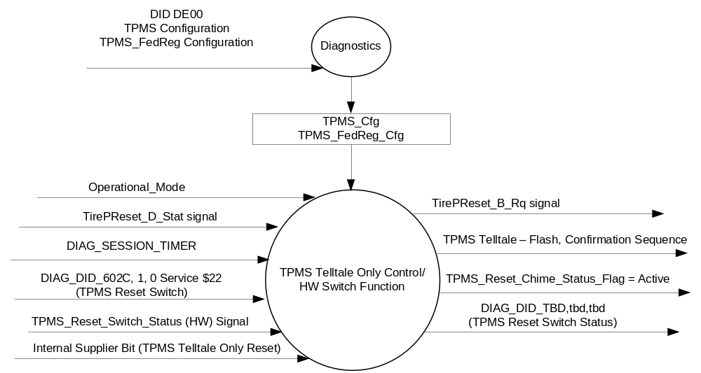

Inputs

      - INTERNAL:
            - DIAG_SESSION_TIMER
            - Operational_Mode
            - DIAG_602C , 1, 0 (TPMS Reset Switch)

        - Mux Signals on the CAN Bus from the Body Control Module (BCM)

- TirePReset_D_Stat Signal
Signal | Size  (bits) | Detail | Units | Res. | Offset | State  Encoded | Min. | Max.
TirePReset_D_Stat | 4 |  | SED | 1 | 0 |  | 0  (0x0) | 3  (0x3)
 |  | Null |  |  |  | 0x0
 |  | Ack |  |  |  | 0x1
 |  | Nack |  |  |  | 0x2

      - TPMS_Reset_Switch_Status (HW) Signal:
1. To be sensed by a micro A/D input port or Digital port
2. Sensing circuit to sink a minimum current of 7 mAmps at 13.25 Volts thru the TPMS Reset switch.
3. To have 0 to 50 ohm input under all operating voltage conditions to be closed, which relates to a Press of the TC_ESC_RSC Switch.
4. TPMS Reset switch will be closed to ground when pressed.

TPMS Reset  Switch Condition | TPMS Reset  Switch Logic | TPMS Reset  Switch Input | Debounce | TPMS_Reset_Switch_Status
Not Pressed | Open | >100k-ohms⁽¹⁾ | 5 samples in a row @10 ms  or 6 samples in a row @8 ms | 0X1 (Not Pressed)
Pressed | Closed | =< 50 ohms | 5 samples in a row @10 ms  or 6 samples in a row @8 ms | 0X0 (Pressed)
(1) Set to 100k-ohms to align with ELCOMP RQT-191001-009863 (EC-0015).

Outputs
- DIAG_DID_602C,1, 0 (TPMS Reset Switch)
- Mux Message on the CAN network

- TirePReset_D_Stat Signal
Signal | Size  (bits) | Detail | Units | Res. | Offset | State  Encoded | Min. | Max.
TirePReset_B_Rq | 4 |  | SED | 1 | 0 |  | 0 (0x0) | 1 (0x1)
 |  | Null |  |  |  | 0x0
 |  | Reset |  |  |  | 0x1

Function/Performance

Operational Modes

Mode | Differentiating Vehicle Conditions
Sleep Mode | No sensing of Switch & TPMS Reset Not Active
Limited Mode | No sensing of Switch & TPMS Reset Not Active
Normal Mode | Sensing of Switch & TPMS Reset Active
Crank Mode | Sensing of Switch & TPMS Reset Active

Voltage Levels

Refer to the Cluster Features table located in the Operational Modes and Voltage Range Strategies Section in this SPSS

Human-Machine Interface

Visual

Indicator Graphics / Display Format
None

Indicator Color Coordinates

See TPMS Telltale Section

Indicator Characteristics

See TPMS Telltale Section

Audio

TPMS Reset Chime upon successful TPMS reset.

System Accuracy

The output of the state matrix, reference 1.3.5.1 Subsystem Algorithm Flowchart/ State Diagram, shall occur within 100msec of a state change.

Operation: Performance and Functional

Subsystem Algorithm Flowchart / State Diagram

- State Matrix for TPMS Reset Switch DID
Operational_Mode | TPMS_Reset  _Switch_Status | DIAG_DID_602C,1,0 (TPMS Reset Switch)
Normal or Crank | 0x1 (Pressed) | 0x1 (Pressed)

Figure 2: TPMS Reset Diagram Using Dedicated TPMS Button and TPMS Telltale Only
(no settings menu or warnings)
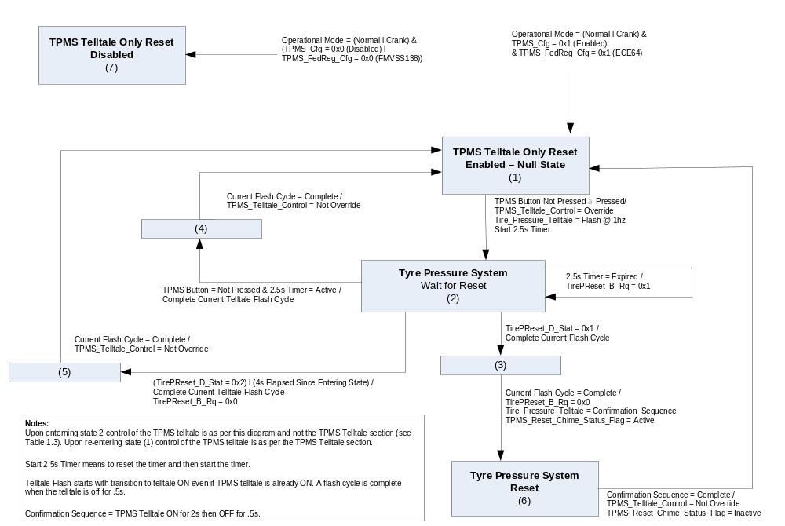

- State Matrix for TPMS Telltale with TPMS Telltale Only Reset Switch ⁽¹⁾
Operational_  Mode | TPMS_Telltale_Control | TPMS_Cfg | ETM Bulb_ Check_State | DIAG_  SESSION_  TIMER | Self_Test_ Entry_Bulb_ Check_Timer | DIAG_DID_  61A5,1,5  (TPMS (Amber) | DIAG_DID_  61A5,4,6  (all warning lamps) | Bulb  _Proveout  _Timer | Tire_Press_Telltale Signal | Tire_ Pressure_Telltale
Normal or Crank | Not Override | Enabled | X | Inactive | X | X | X | Active | X | ON
Normal or Crank | Not Override | Enabled | X | Inactive | X | X | X | X | On (0x1) | ON
Normal or Crank | Not Override | Enabled | OFF (0x0) | Inactive | X | X | X | Inactive | Flash (0x2) | Flash @1Hz 50% Duty Cycle
Normal or Crank | Not Override | Enabled | OFF (0x0) | Inactive | X | X | X | Inactive | Not_Used (0x3) | See Section 1.4.1
Normal or Crank | Not Override | Enabled | OFF (0x0) | Inactive | X | X | X | Inactive | Declared missing | See Section 1.4.1
Normal or Crank | Not Override | Enabled | OFF (0x0) | Inactive | X | X | X | Inactive | Never Received | ON  then as per Section 1.4.1
Normal or Crank | Not Override | Enabled | ON (0x1) | Inactive | X | X | X | X | X | ON
Normal or Crank | Override | X |  |  |  |  |  |  |  | (2) Below
Normal | Not Override | Enabled | X | Active | Inactive | Not Received | Not Received | Active | X | ON
Normal | Not Override | Enabled | X | Active | Inactive | Not Received | Not Received | X | On (0x1) | ON
Normal | Not Override | Enabled | OFF(0x0) | Active | Inactive | Not Received | Not Received | Inactive | Flash (0x2) | Flash @1Hz 50% Duty Cycle
Normal | Not Override | Enabled | OFF(0x0) | Active | Inactive | Not Received | Not Received | Inactive | Not_Used (0x3) | See Section 1.4.1
Normal | Not Override | Enabled | OFF(0x0) | Active | Inactive | Not Received | Not Received | Inactive | Declared missing | See Section 1.4.1
Normal | Not Override | Enabled | OFF(0x0) | Active | Inactive | Not Received | Not Received | Inactive | Never Received | ON  then as per Section 1.4.1
Normal | Not Override | Enabled | ON (0x1) | Active | Inactive | Not Received | Not Received | X | X | ON
Normal | Not Override | Enabled | X | Active | X | ON (0x1) | X | X | X | ON
Normal | Not Override | Enabled | X | Active | X | X | ON (0x1) | X | X | ON
Normal | Not Override | Enabled | X | Active | Active | X | X | X | X | ON
Normal | Override | X |  |  |  |  |  |  |  | (2) Below
All Other Cases |  |  |  |  |  |  |  |  |  | Off

Notes relative to Table 1.3 above:
- This truth table directly replaces the like truth table in TPMS Telltale v2.0 only for applications where the TPMS reset using only the Telltale/Chime function is employed as per this section. It was not desired to update the Telltale TPMS STSS with this function for this extremely low program implementation because we do not want the vast majority of programs to have to evaluate what TPMS_Telltale_Control means when it is only employed on 1 or 2 applications.
- Function is as per Figure 2 of this section.

Supplier or IPC Applications engineer must verify that v2.0 of TPMS Telltale STSS is used on their program. If a later version is used then supplier/IPC applications engineer must review TPMS Telltale STSS as to whether the above truth table must be updated.

Operation Description (supports algorithm flowchart /state diagram)

Function Safety Classification (EMC)

B

Memory Storage
Parameter Name | Description | Value at  Battery Connect | Value at  Module Wake-up
TPMS_Reset_Switch_Status | Indicates the state of the HW Switch input | Not Pressed (0x1) | Not Pressed (0x1)
TirePReset_D_Stat signal | CAN signal input | Null (0x0) | Null (0x0)
TirePReset_B_Rq | CAN signal output | Null (0x0) | Null (0x0)
DIAG_DID_602C,1,0 (TPMS Reset Switch) | TPMS Reset Switch, byte 1, bit 0 | Not Pressed (0x0) | Not Pressed (0x0)
Operational_Mode | 4 state indicator for cluster operational mode | Limited | Limited, Normal or Crank

Parameter Name | Description | Value at  Battery Connect | Value at  Module Wake-up
DIAG_SESSION_TIMER | Timer used to time-out a diagnostic session | Inactive | Inactive

Prove Out
No

Reconfigurable Telltale
No.

Message Center Msg
No.

Error Handling
There is no error detection for this switch since there are only two states.

Missing Message Strategy

NA

Diagnostics

Self Test

None

Engineering Test Mode

Reference section “Dealer / Engineering Test Mode (ETM)”.

Part II Performance

Supported Diagnostic DIDs (Service $22 and $2F)
Number | DID / CommonID Name | DID Type
602C | DIAG_DID_602C,1,0 (TPMS Reset Switch) | Bit Mapped

Supported Diagnostic Trouble Codes (DTCs)
DTC | Description | When Logged
None

DID $DExx:
Block  Num | Block Description | Byte(s) | Bits | State: Description | "0" | "1" | Default | Comments/  Information
PACKETED BLOCKS
$xx | Option Content (B&A) | * | * | TPMS Configuration | Disabled | Enabled | Enabled | Not Dealer Configurable
$xx | Option  Content (B&A) | * | * | TPMS FedReg Config | FMVSS138 | ECE64 | FMVSS138 | Not Dealer Configurable

Reference Specification

IS-0052 OPERATING VOLTAGES - FUNCTIONAL/PERFORMANCE
IS-0069 FUNCTIONAL IMPORTANCE CLASS

03-0661 PLACEMENT: CONTROL AND DISPLAY LOCATIONS
03-0662 PLACEMENT: LOGICAL GROUPING FUNCTION AND USAGE
03-0664 PLACEMENT: DOWN VISION TO COMPONENTS WITH HIGH VISUAL DEMAND
03-0665 PLACEMENT: EXPECTED LOCATIONS OF CONTROLS AND DISPLAYS VDS
03-0670 INTERIOR VISIBILITY
03-0671 INTERIOR VISIBILITY: REFLECTIONS FROM COMPONENTS & SURFACES
03-0672 INTERIOR VISIBILITY: REFLECTIONS IN DISPLAYS
03-0673 INTERIOR VISIBILITY: VISUAL OBSCURATIONS
03-0674 INTERIOR VISIBILITY: ILLUMINATION CONTROLS / DISPLAYS
03-0675 INTERIOR VISIBILITY: VEILING GLARE
03-0677 INTERIOR VISIBILITY: SUNLIGHT WASHOUT
03-0681 IDENTIFICATION: CHARACTER AND SYMBOL SIZE
03-0682 IDENTIFICATION: LEGIBILITY
03-0685 IDENTIFICATION: SYMBOLS, ABBREV FOR CONTROL
03-0721 LOGIC OF OPERATION: OPERATIONAL STEREOTYPES
03-0722 LOGIC OF OPERATION: INTERPRETATION
03-0723 LOGIC OF OPERATION: USE OF SYSTEMS WITH VISUAL DISPLAYS
EC-0128 SWITCH CONTACT RESISTANCE

Revision History

SPSS Module Revision History

Revision Level | Name | Change Description | Date
1.0 | J. Blatchford | Initial Release – Note only used on base IPC without capability to control TPMS reset through the settings screen. Released less DID | 8/3/2016
1.1 | J. Blatchford | Minor update to replace TBD DID with actual DID.  - Replaced TBD DID with DID 602C, 1, 0, (TPMS Reset Switch) throughout document.  - Figure 2: Clarified State (2) naming to more clarely reflect entry conditions. | 9/3/16

